2. Account Maintenance

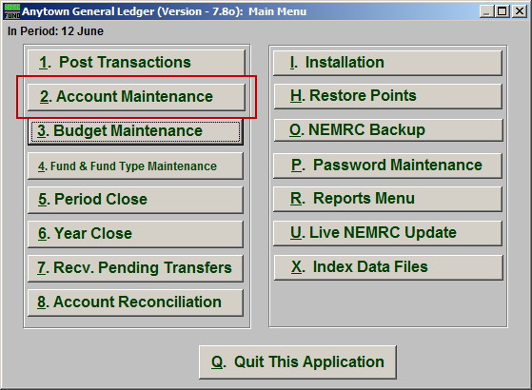
Click on “2. Account Maintenance” from the Main Menu and the following window will appear:

Account Maintenance

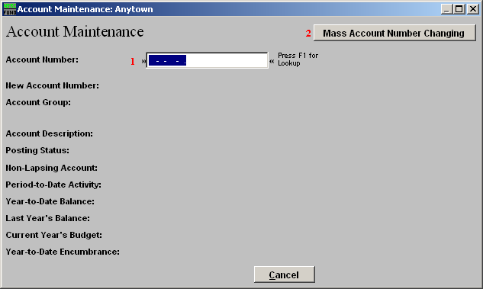
- Account Number: Enter the General Ledger account to add or edit to the system. You may also use the F1 function key to find an account from the lookup table. If you have a variable length structured chart of accounts then a message will appear with what types of accounts can be added or edited. Use the enter key to change the group selection when the variable length account number has been defined.

- Mass Account Number Changing: This is a tool which allows redefining or redesigning your chart of accounts. Contact NEMRC support for a discussion on your needs and guidance to proceed.

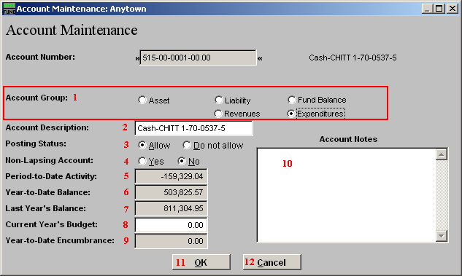
- Account Group: Select what group this account is in.

- Account Description: Enter the description to appear on reports for this account.

- Posting Status: Select the option to allow or not allow postings to this account.

- Non-Lapsing Account: Select “No” if the budget assigned to this account is not allowed to carry over the un-used portion. Select ‘Yes’ if it is allowed to carry over un-used budget amounts.

- Period-to-Date Activity: This is this account’s Period-to-Date activity.

- Year-to-Date Balance: This is this account’s Year-to-Date balance.

- Last Year’s Balance: This is this account’s Last Year budget.

- Current Year’s Budget: Enter this account’s Current Year budget.

- Year-to-Date Encumbrance: This is this account’s Year-to-Date Encumbrance.

- Account Notes: This is a user defined field.

- OK: Click “OK” to save changes and return to the Main Menu.

- Cancel: Click “Cancel” to cancel and return to the previous screen.

